**create single node hadoop cluster having the machine name as your name and upload the project data in HDFS .**

**upload all the screenshots that would describe the steps taken in completing this assignment**

**Step 1:- *enable the network connection***

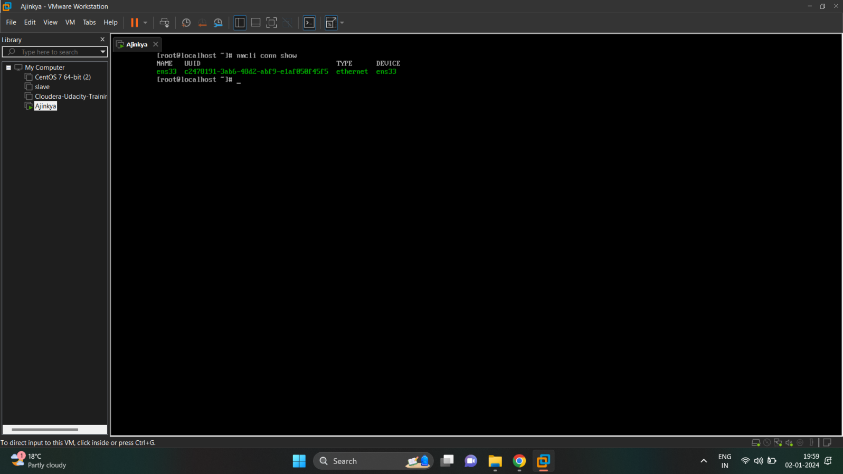

***Step 2:- Installation of JDK****-*

*- Moving Tar file from local to VM root folder using FileZila tool.*

*.****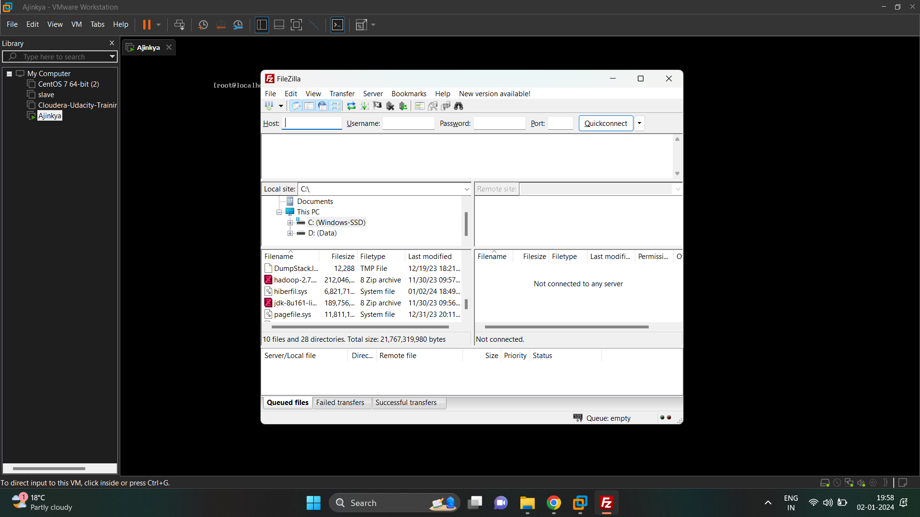***

- After moving file we have extract those file using tar -xvf command and convert it into executable file

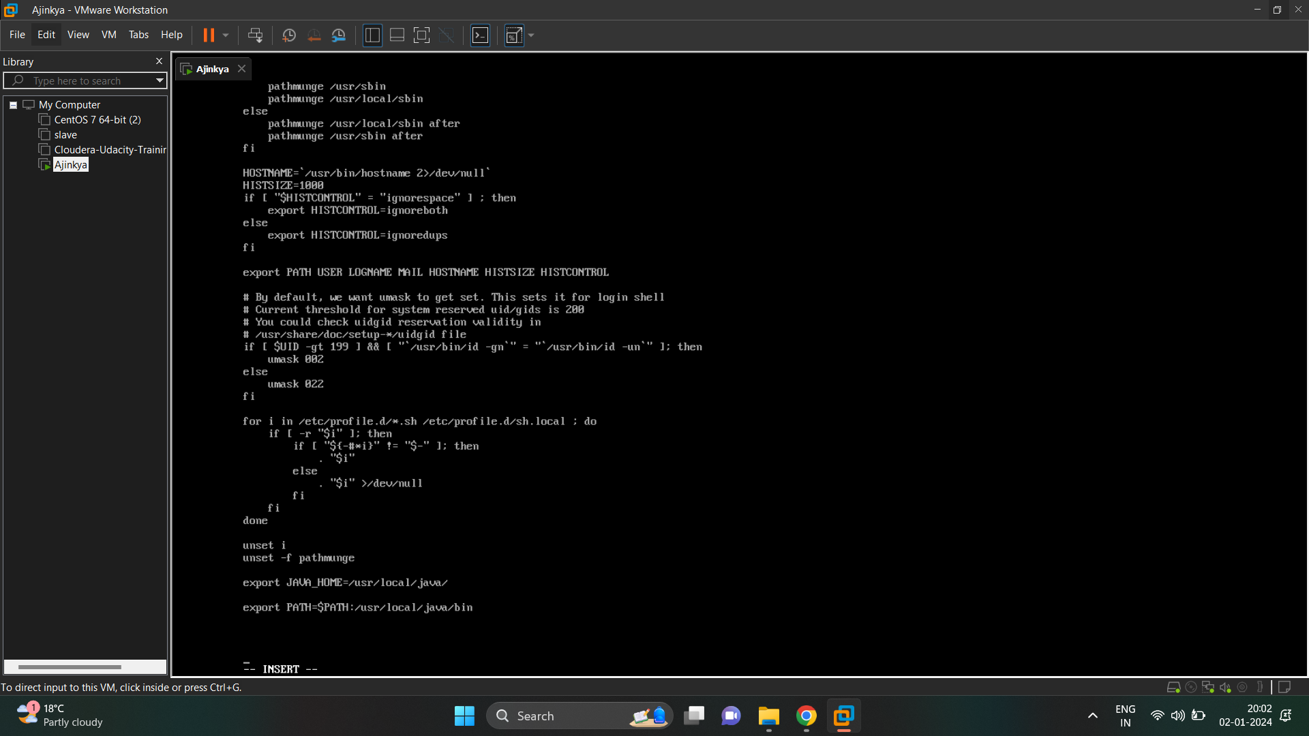

- after that move the jdk file into /usr/local by renaming the file to java using mv command

- set the environment variables located in /etc/profile by ‘vi’ command vi /etc/profile

Add below code into above file

**export JAVA_HOME=/usr/local/java/**

**export PATH=$PATH:/usr/local/java/bin**



- refresh the file using source command ( source /etc/profile)

- then check whether JPS is running or not using (jps) command

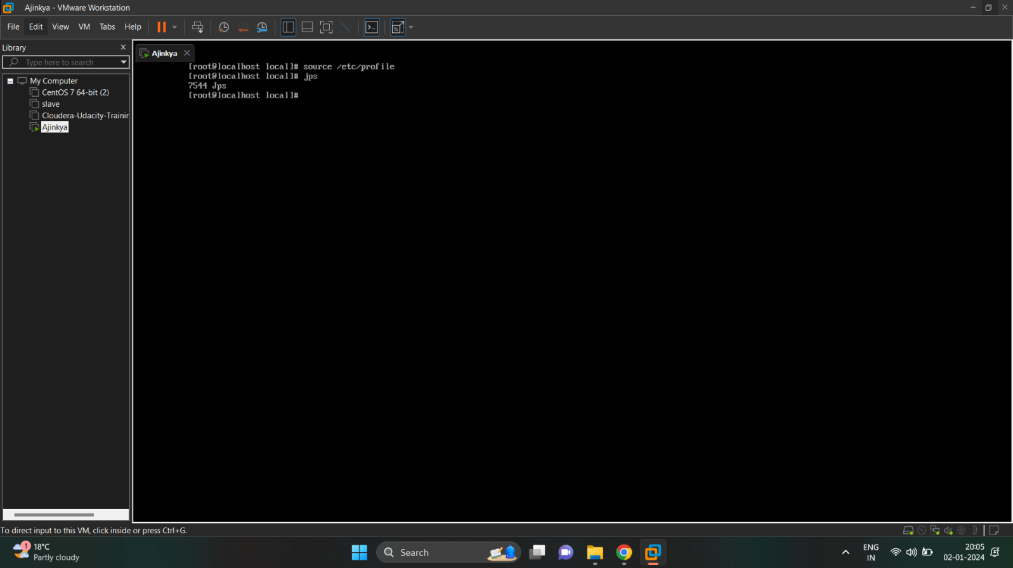

**Step 3 :- Hadoop Installation**

- extract that tar file using (tar -xvf) command then move and rename that file into /usr/local

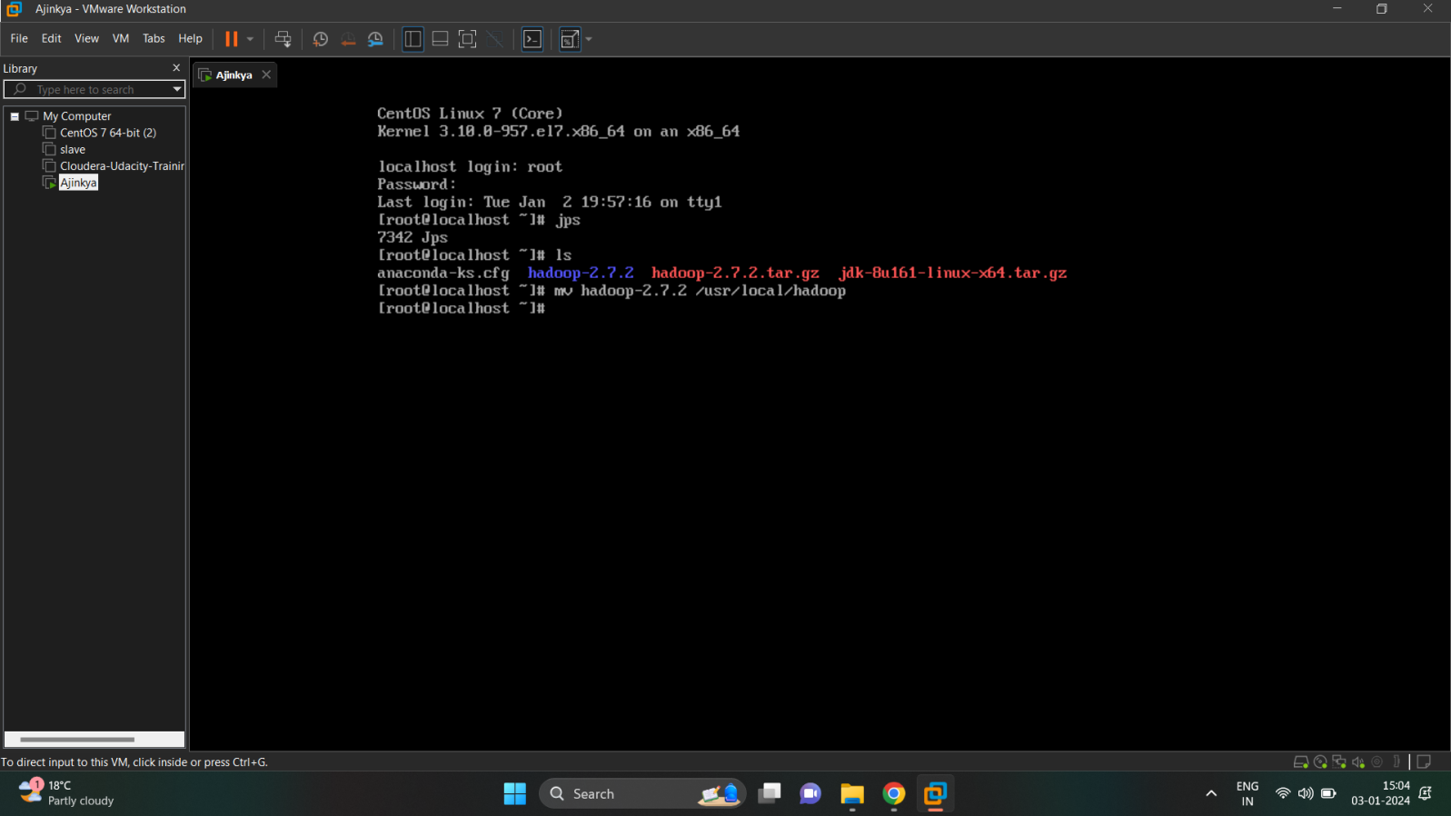

- set the environment path in /etc/profile using ‘vi’ command and add below code

export HADOOP_HOME=/usr/local/hadoop

export HADOOP_INSTALL=$HADOOP_HOME

export HADOOP_MAPRED_HOME=$HADOOP_HOME

export HADOOP_COMMON_HOME=$HADOOP_HOME

export HADOOP_HDFS_HOME=$HADOOP_HOME

export YARN_HOME=$HADOOP_HOME

export HADOOP_COMMON_LIB_NATIVE_DIR=$HADOOP_HOME/lib/native

export PATH=$PATH:$HADOOP_HOME/sbin:$HADOOP_HOME/bin

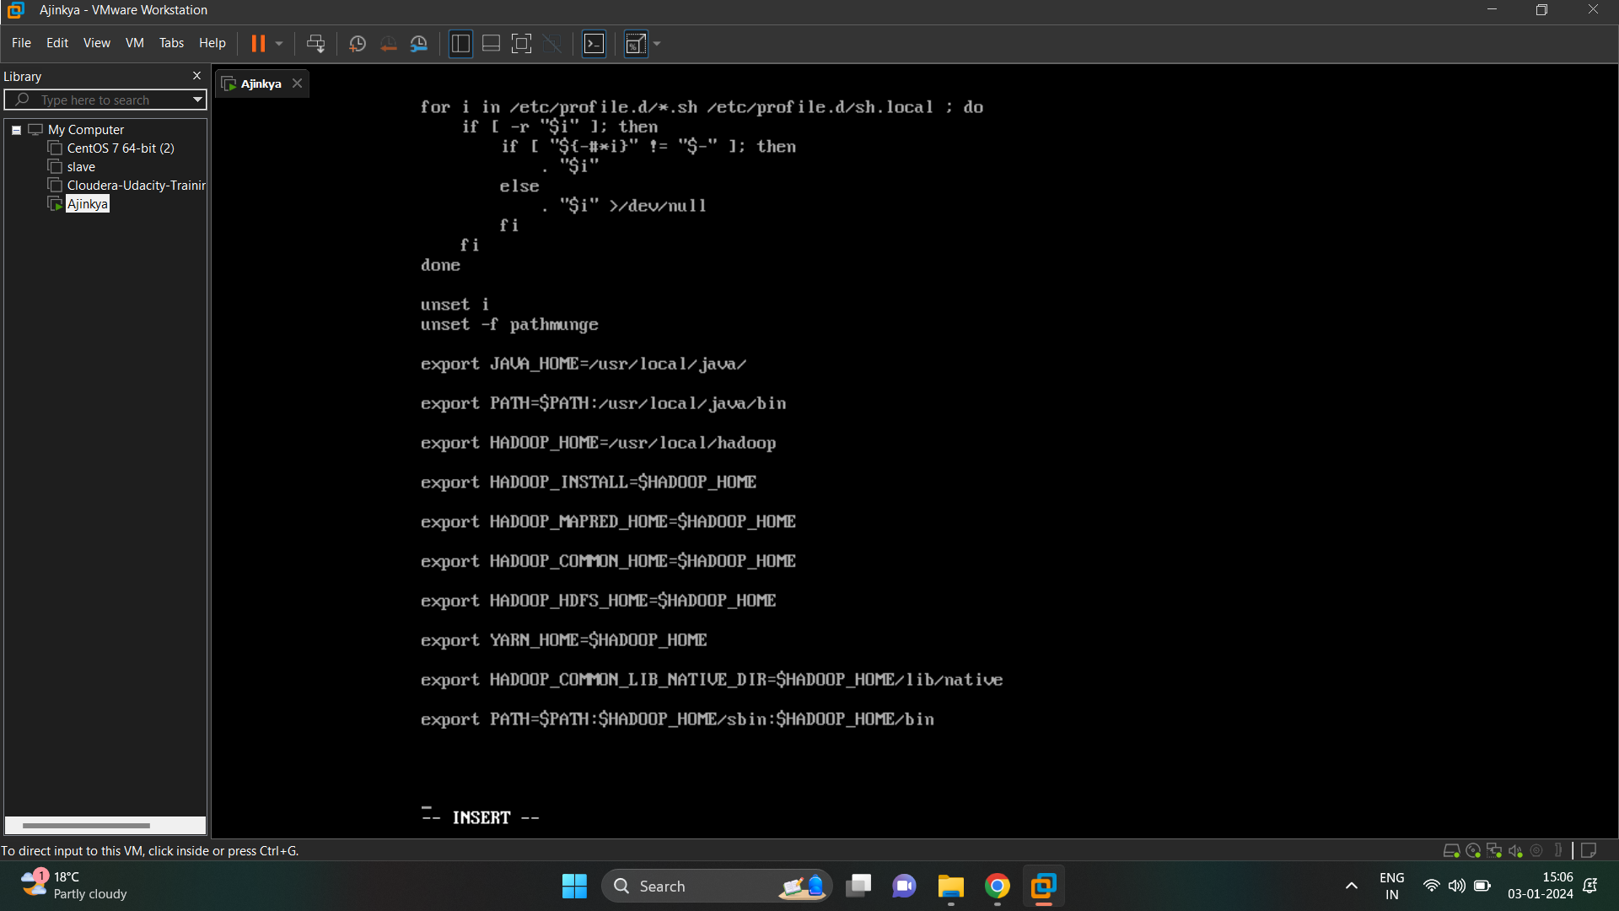

- set the java path into hadoop-env.sh which is located in /usr/local/hadoop/etc/hadoop and add java path

(export JAVA_HOME=/usr/local/java)

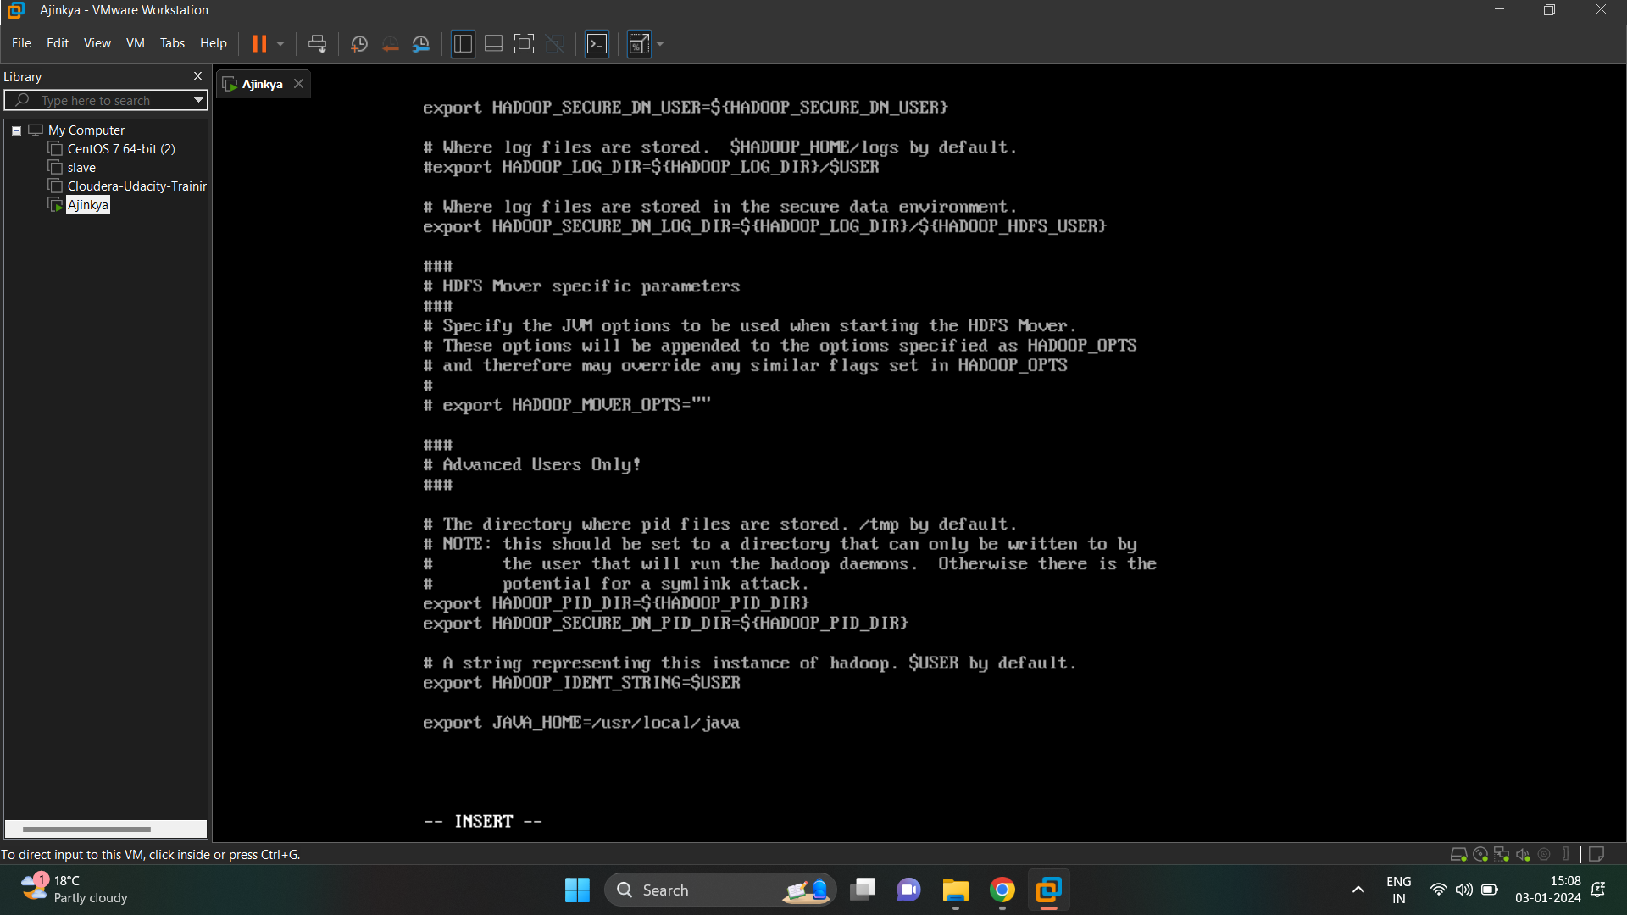

- configure required XML files

- core-site.xml

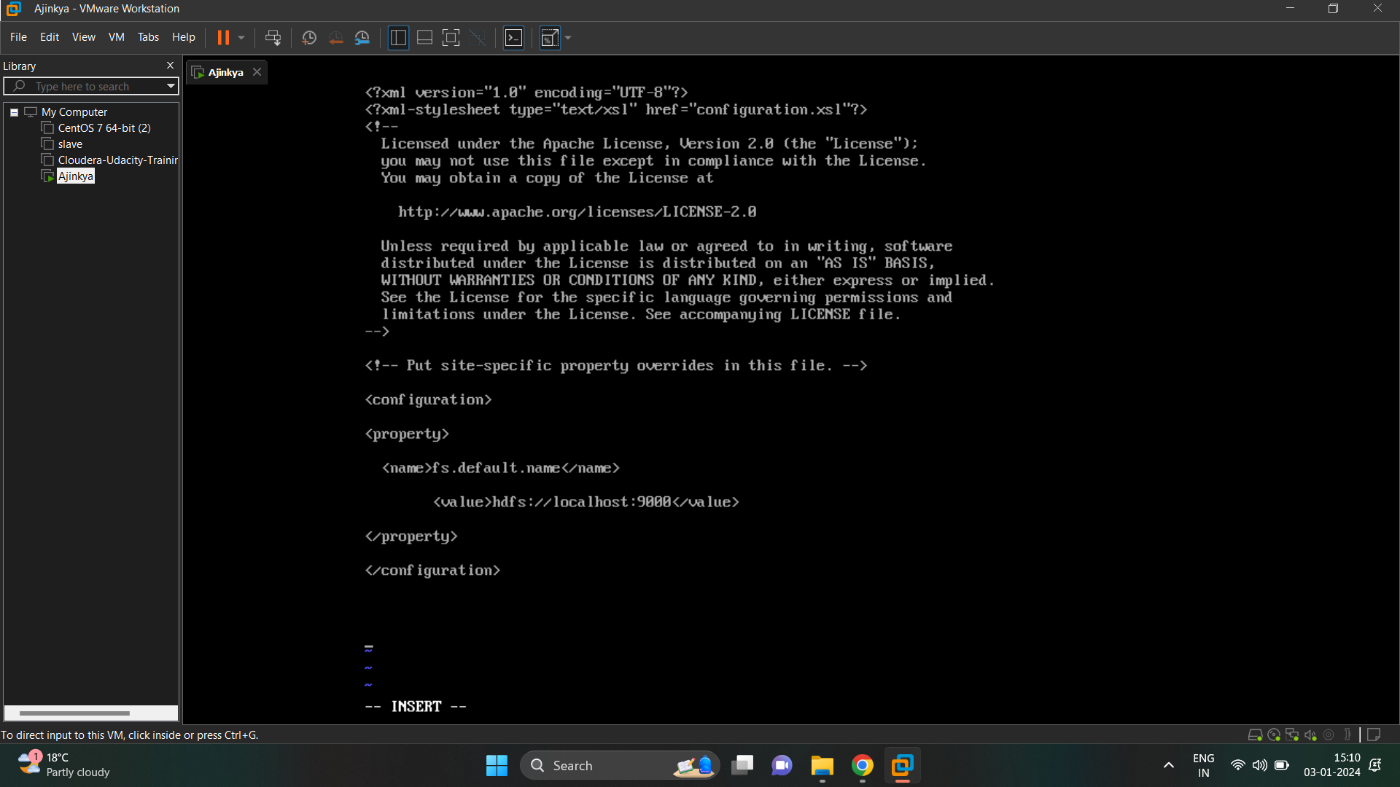

- hdfs-site.xml

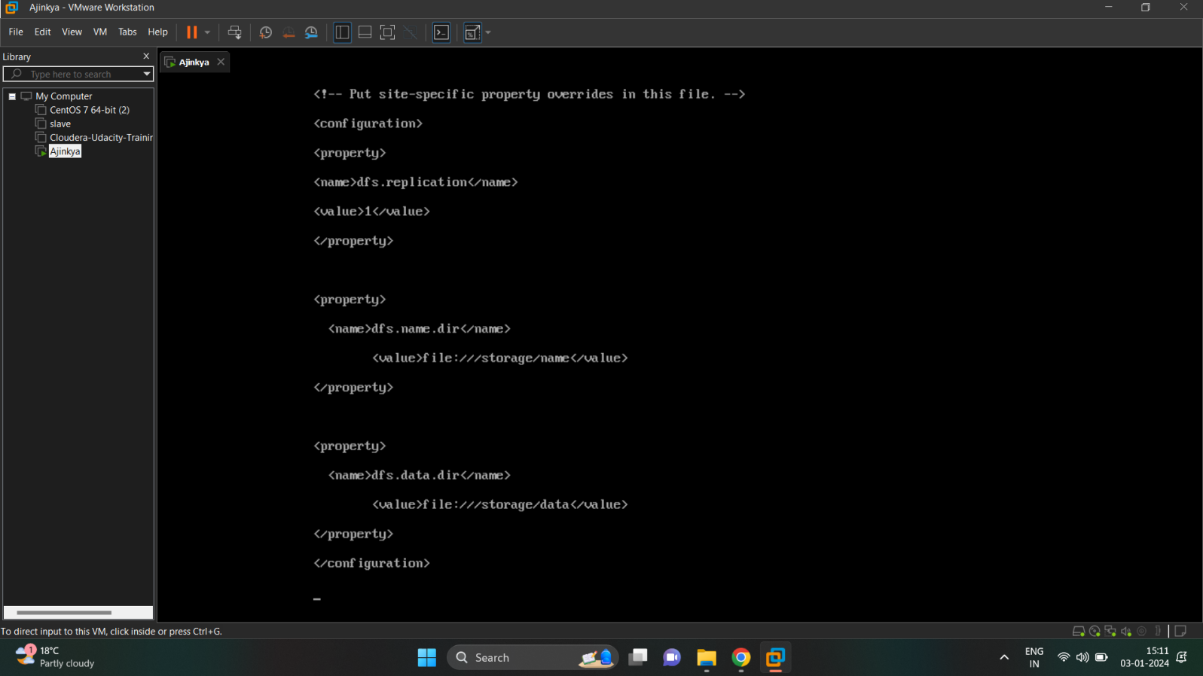

- mapred-site.xml :- Firstly, rename the file name from mapred-site.xml.template to mapred-site.xml using mv command (mv mapred-site.xml.template mapred-site.xml ) then configure the file

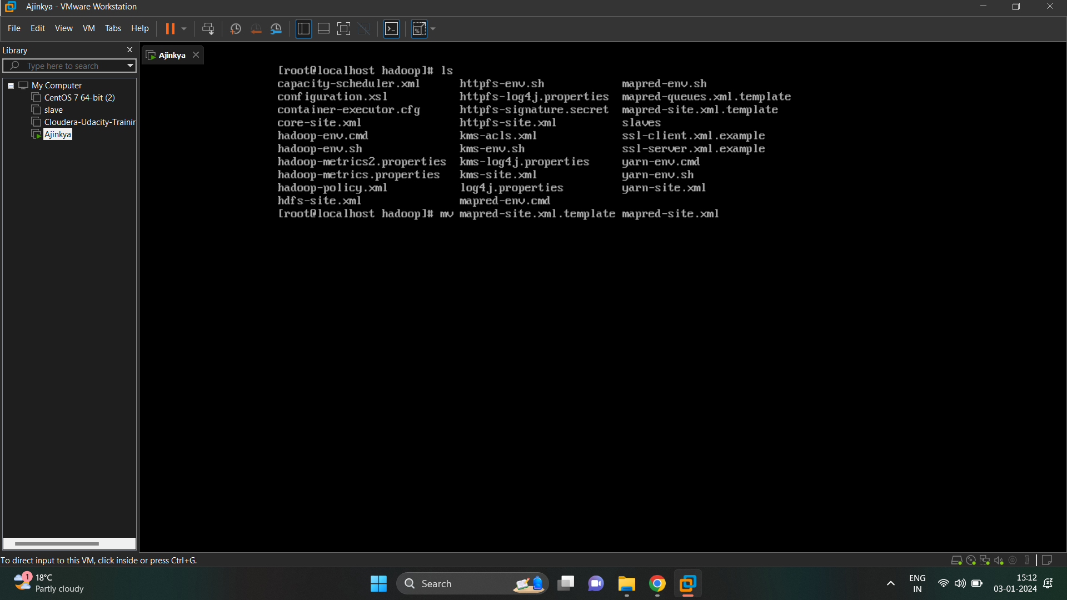

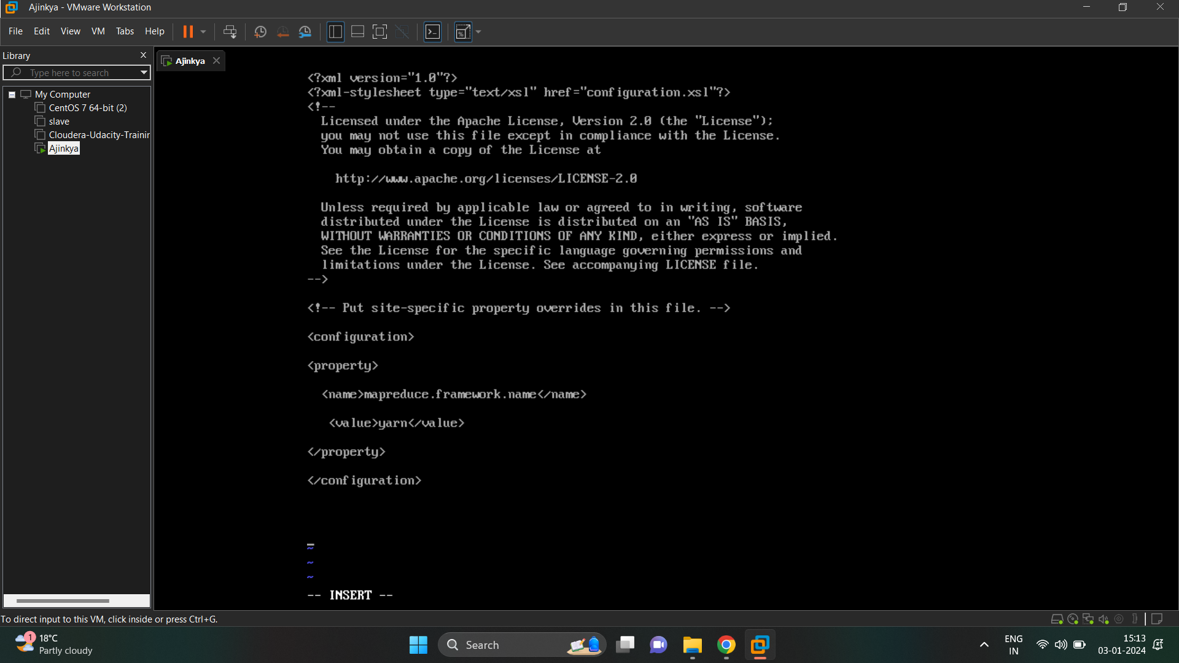

- yarn-site.xml configuration

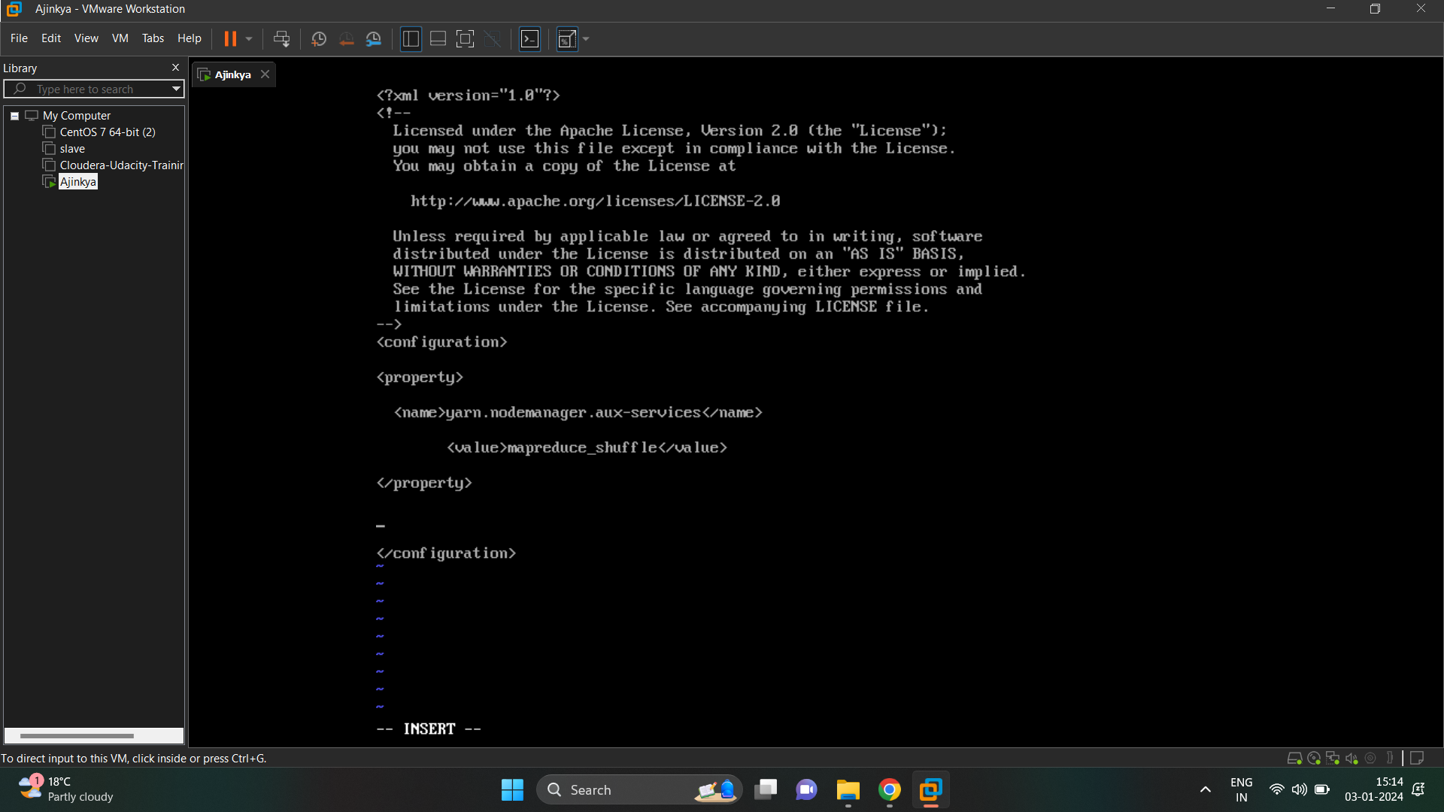

- Format the namenode (hdfs namenode -format)

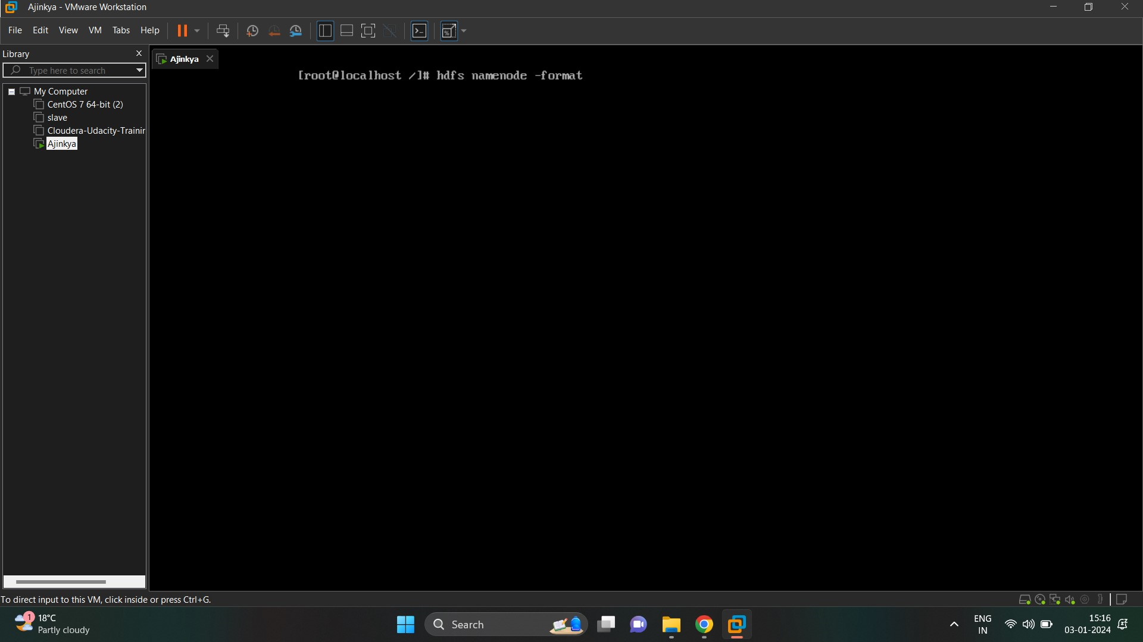

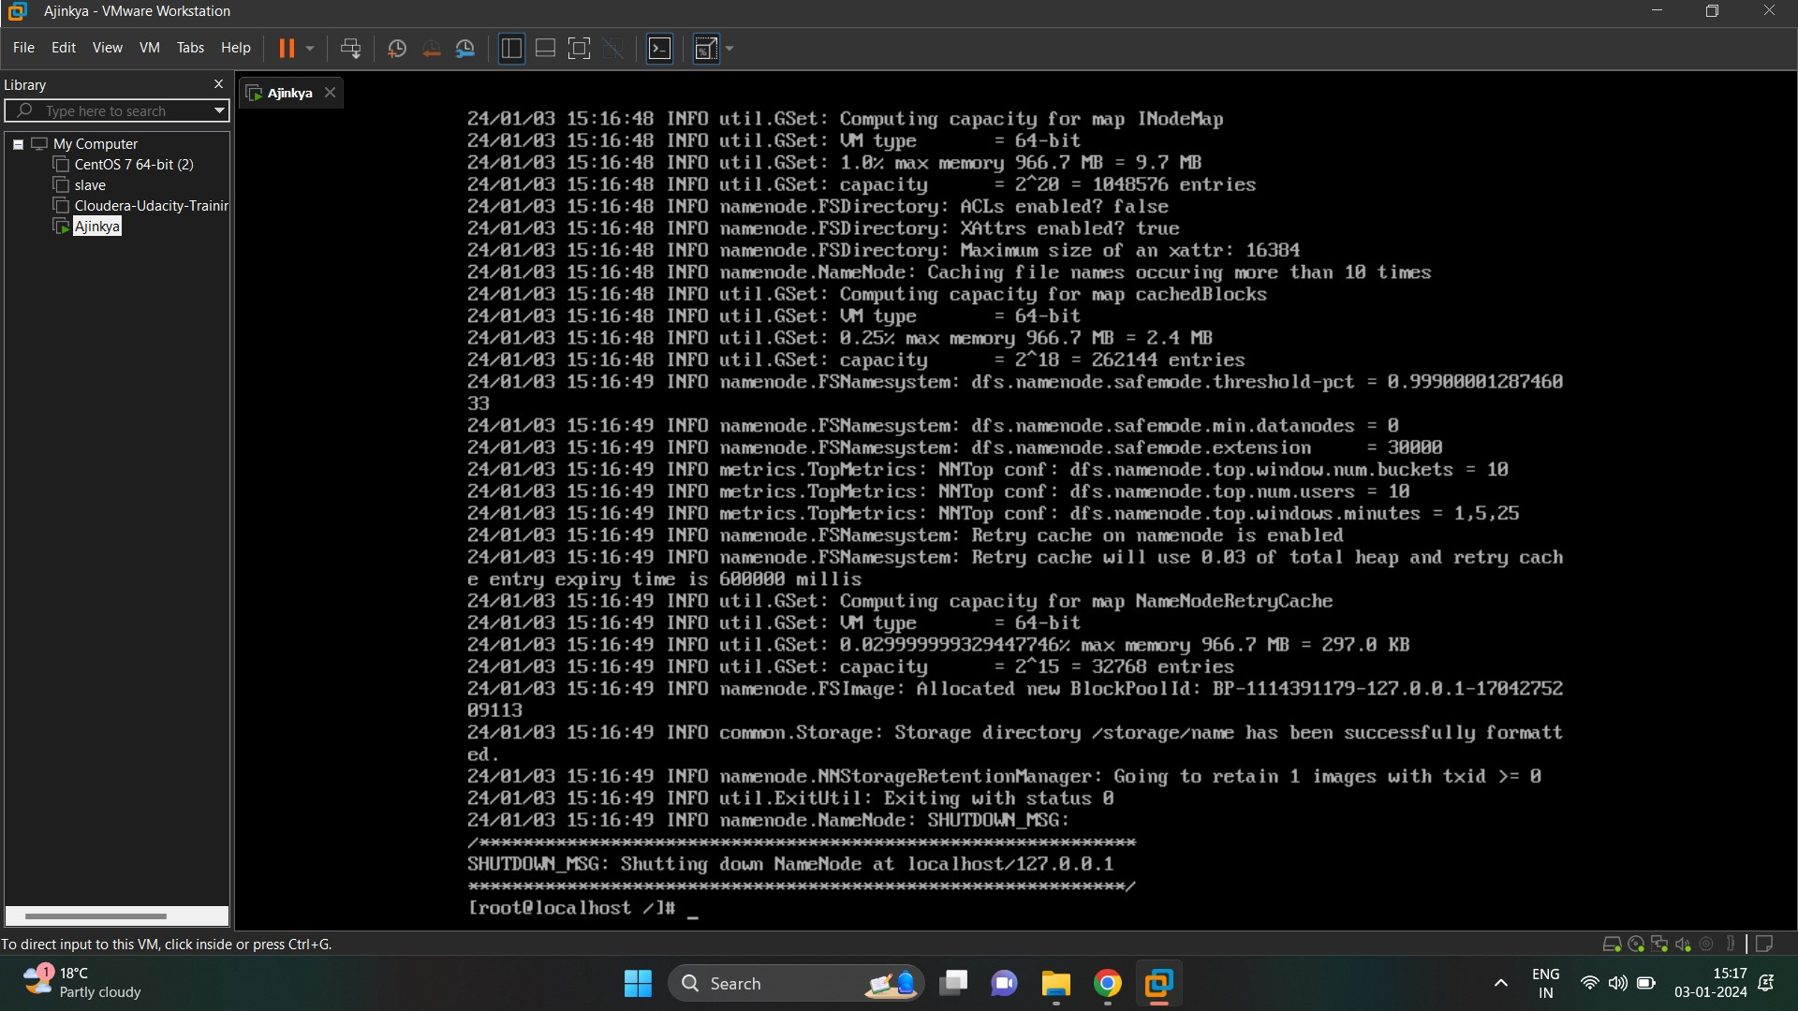

- need to start all the services of hdfs and yarn. Go to sbin directory located in /usr/local/hadoop which contains all shell scripted file (.sh)

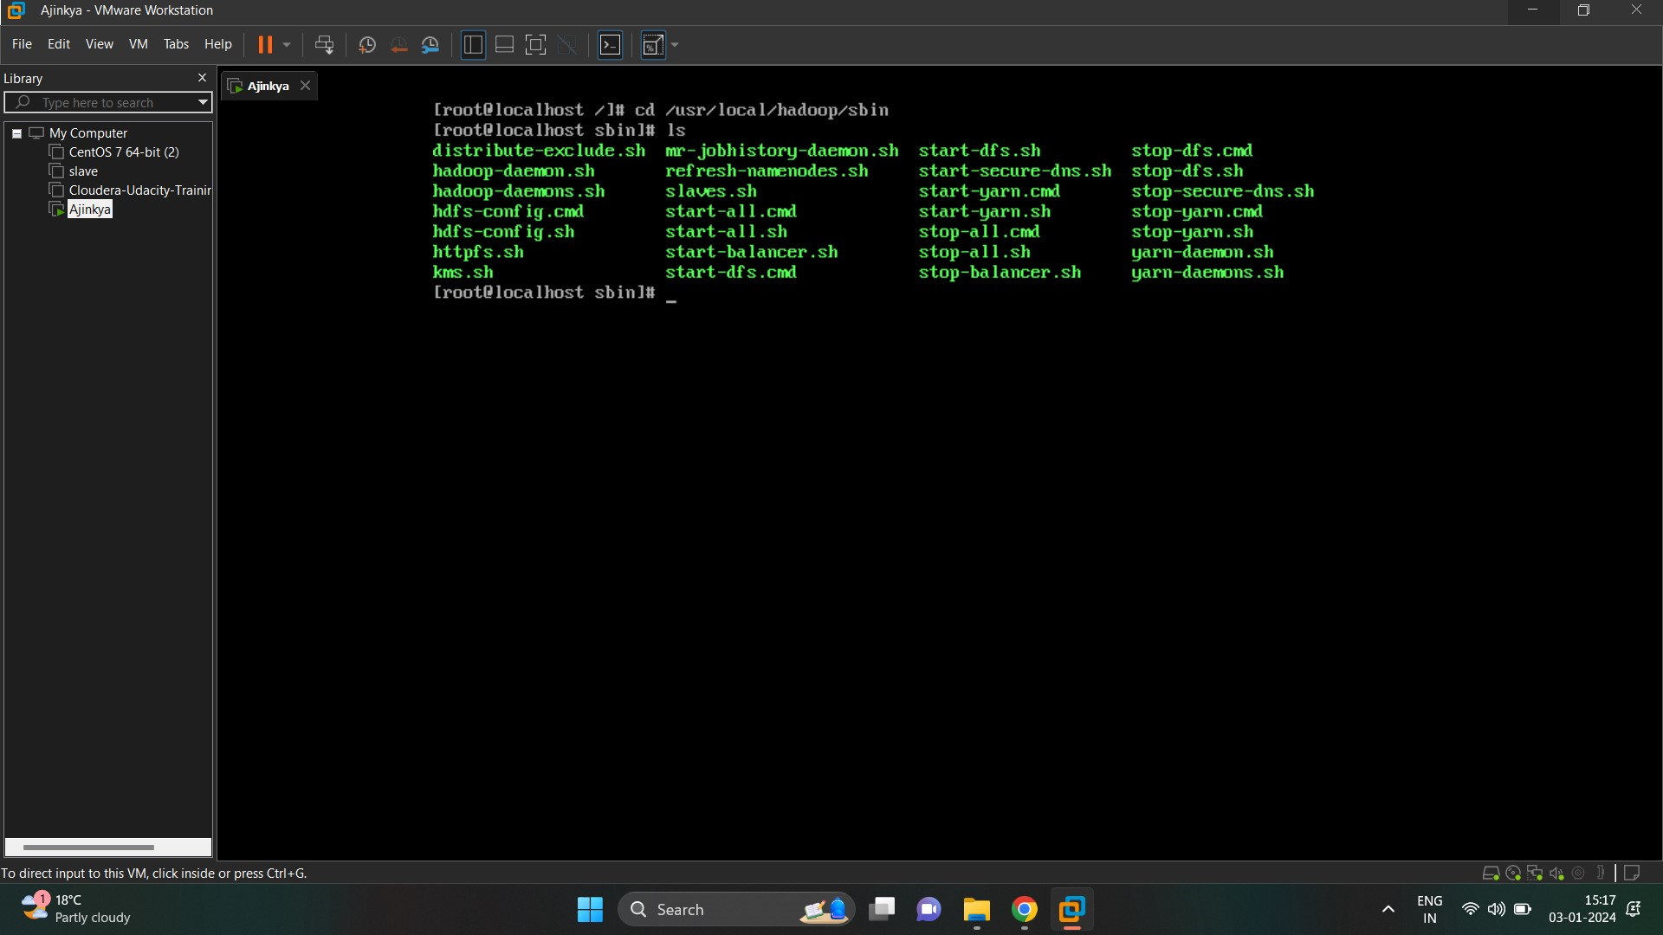

- start dfs components (namenode, secondary namenode and datanode) by running “ sh start-dfs.sh” command. After that type jps for checking whether all the componets are started or not.

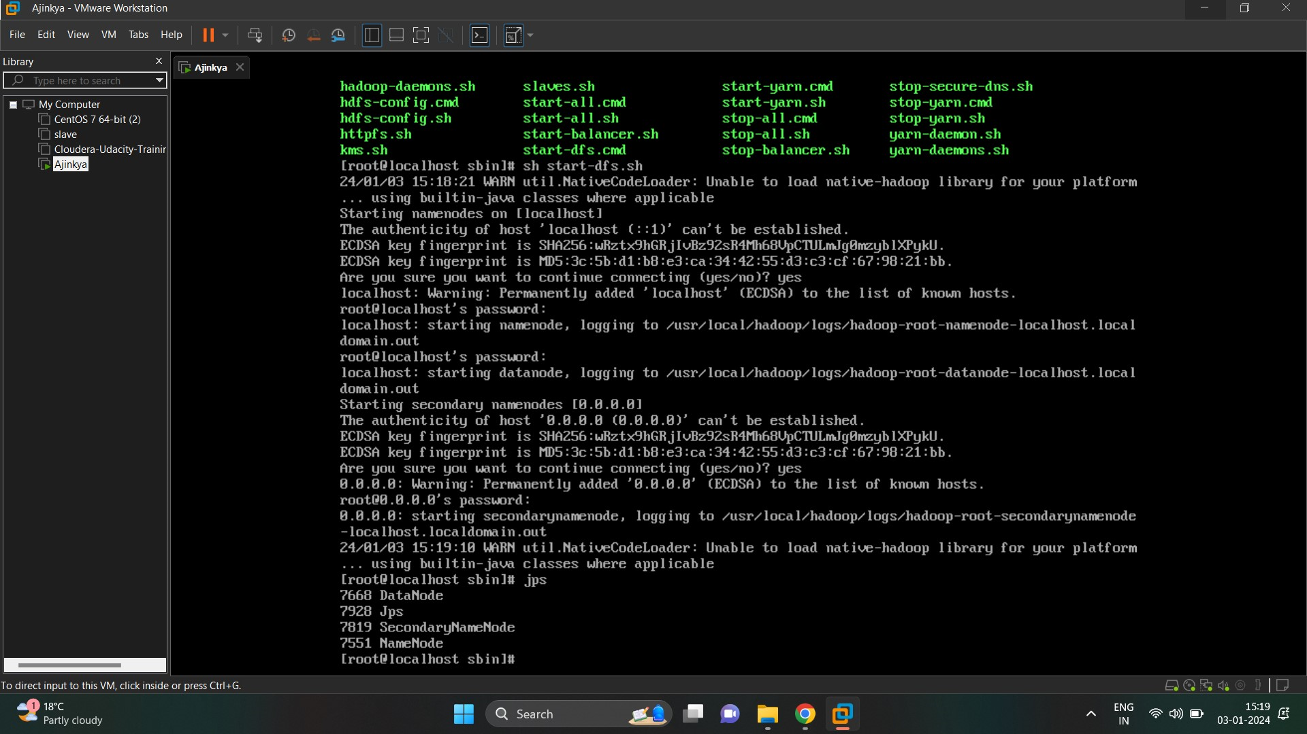

- start yarn components ( resource manager, node manager) by running “ sh start-yarn,sh” command and type jps for checking services.

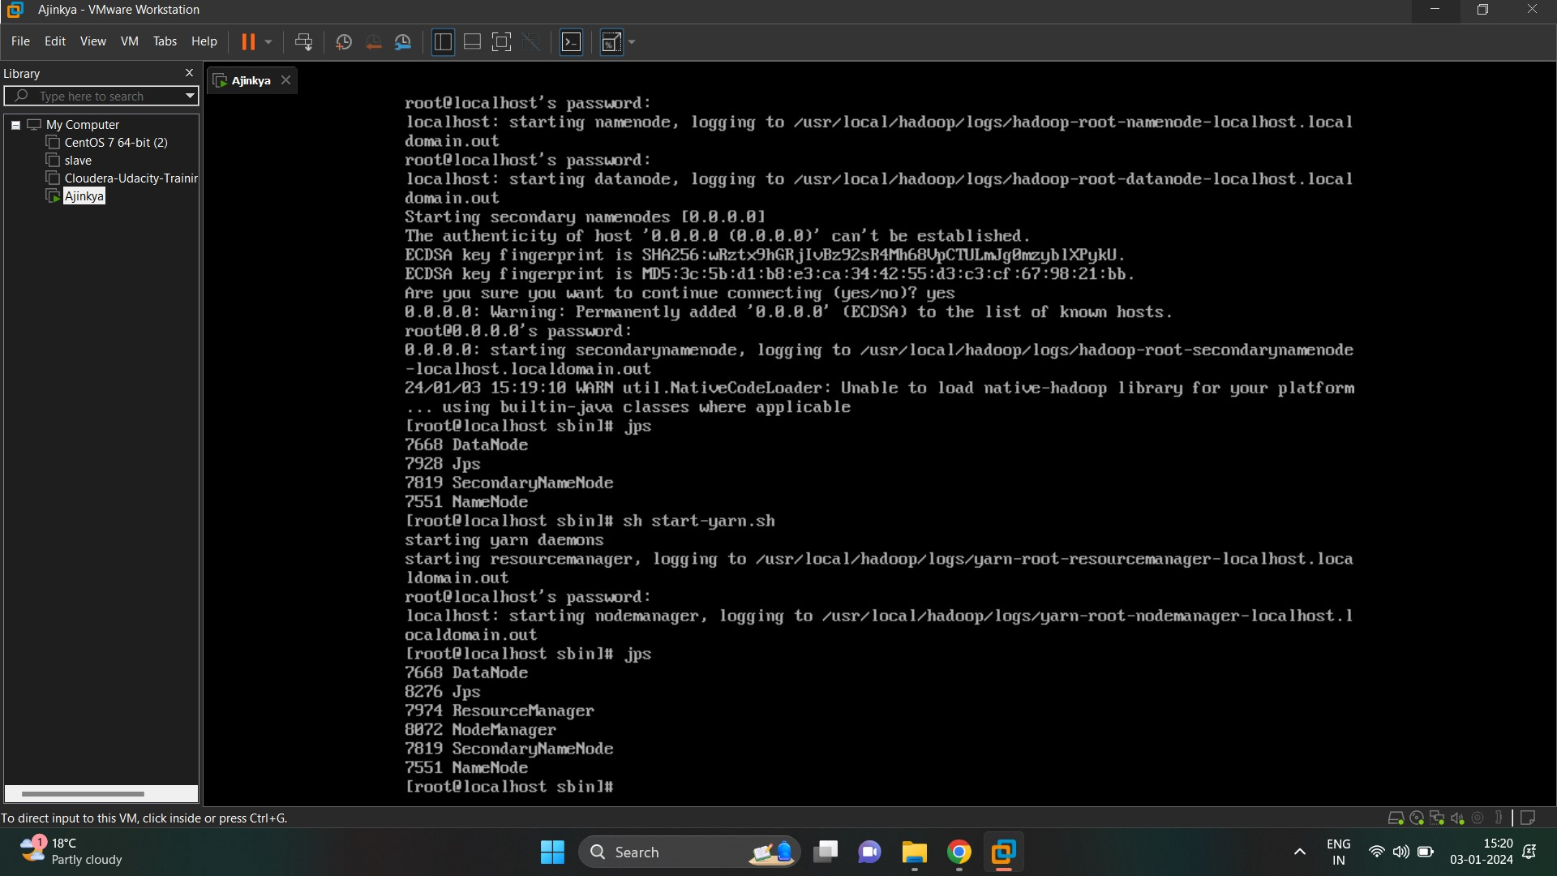

**Step 4 :- Accessing Hadoop GUIs**

Open search box of window, type run and open drivers. Then open etc folder and copy hosts file to desktop and open in notepad, add IP address where the hadoop is running.

Again copy that file and replace it into etc folder.

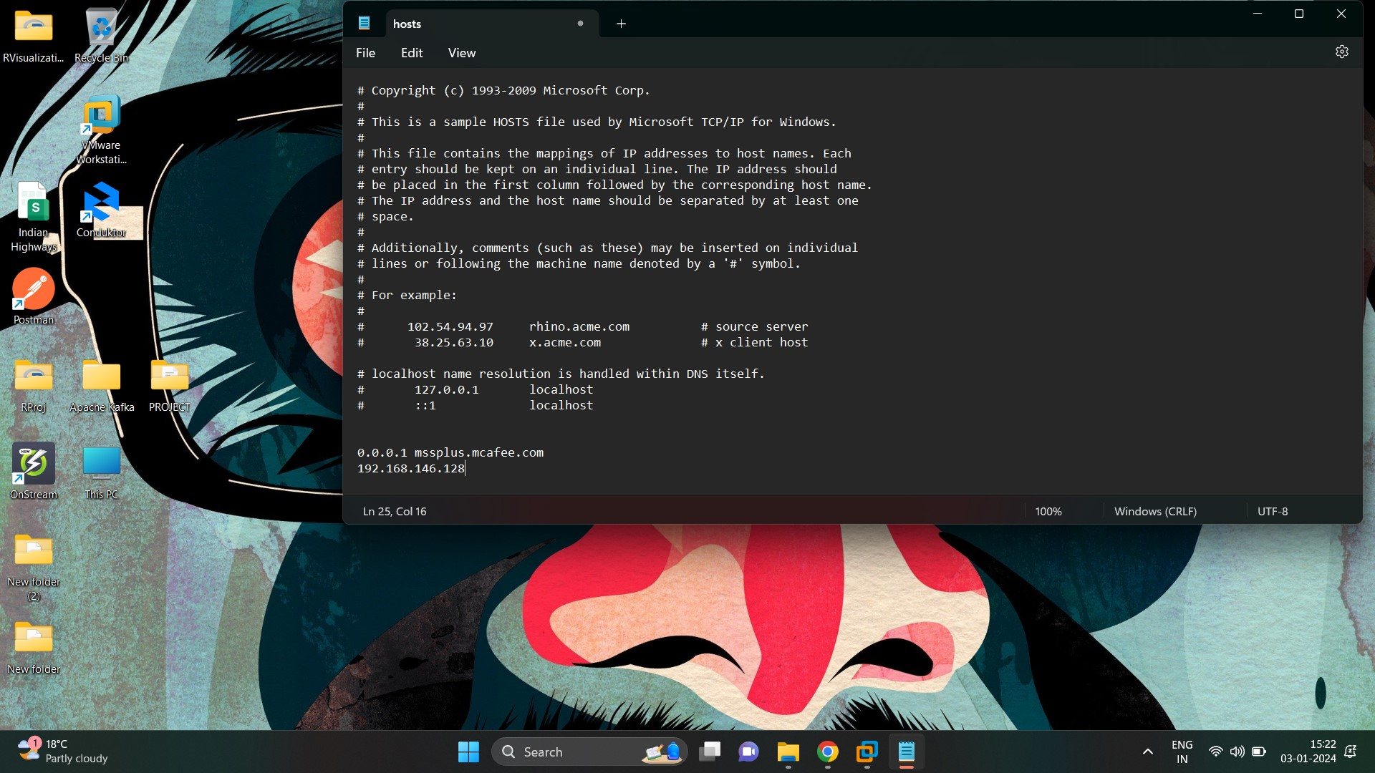

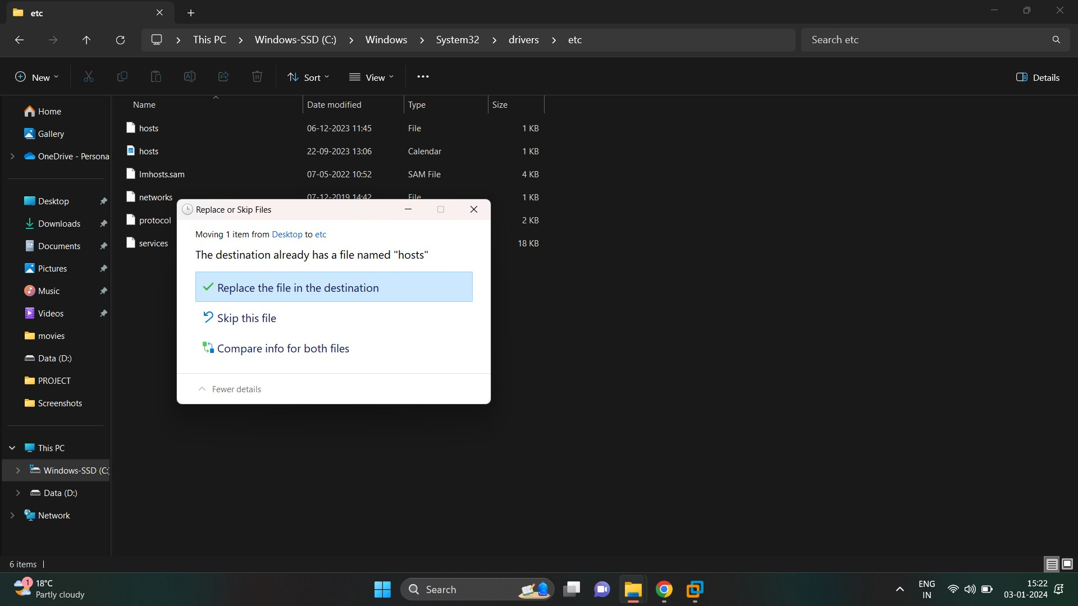

- disable the firewalls using belows commands

Sudo systemctl stop firewalld (used to stop firewall)

Sudo systemctl disable firewalld (for disabling firewall)

Sudo systemctl status firewalld (for checking status of firewall)

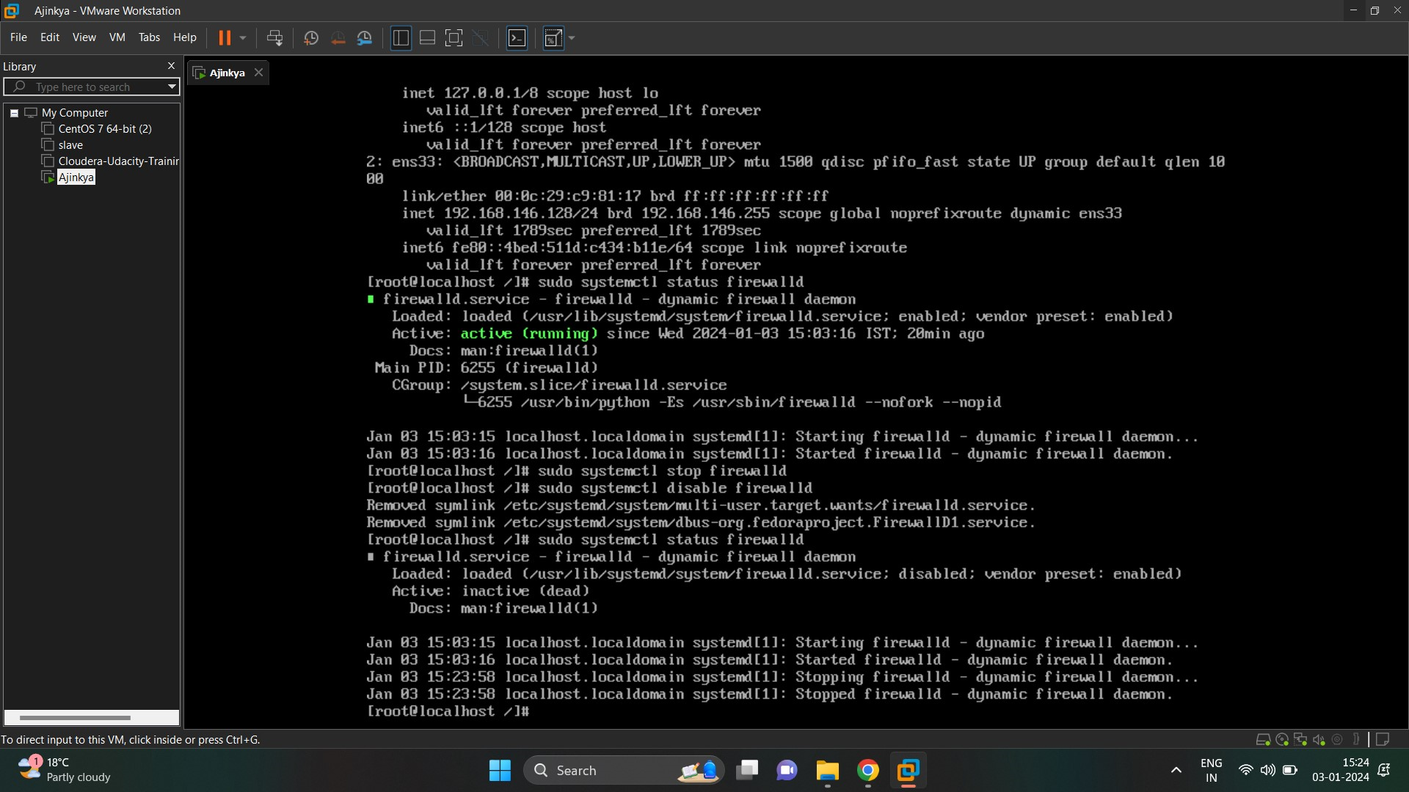

- start any browser type ( ip_address:50070) for accessing HDFS GUI

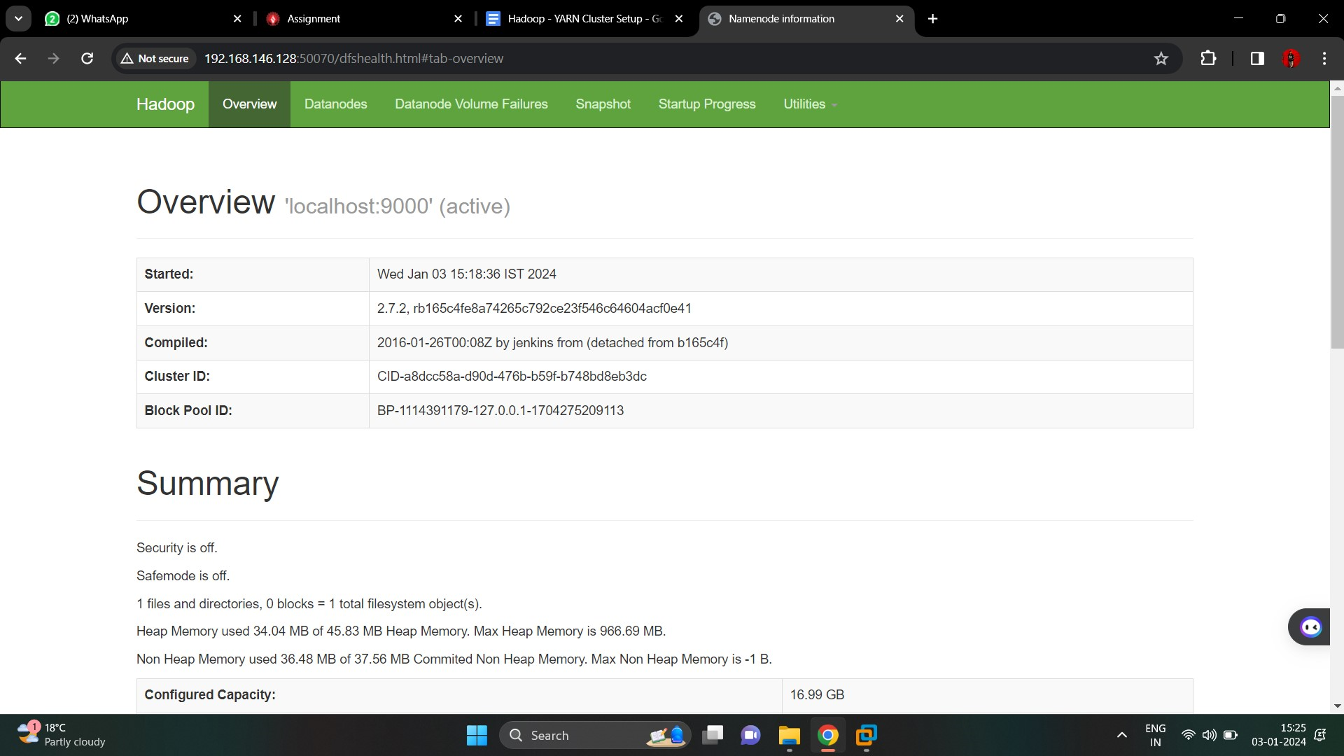

- (ip_address:8088) for accessing resource manager GUI

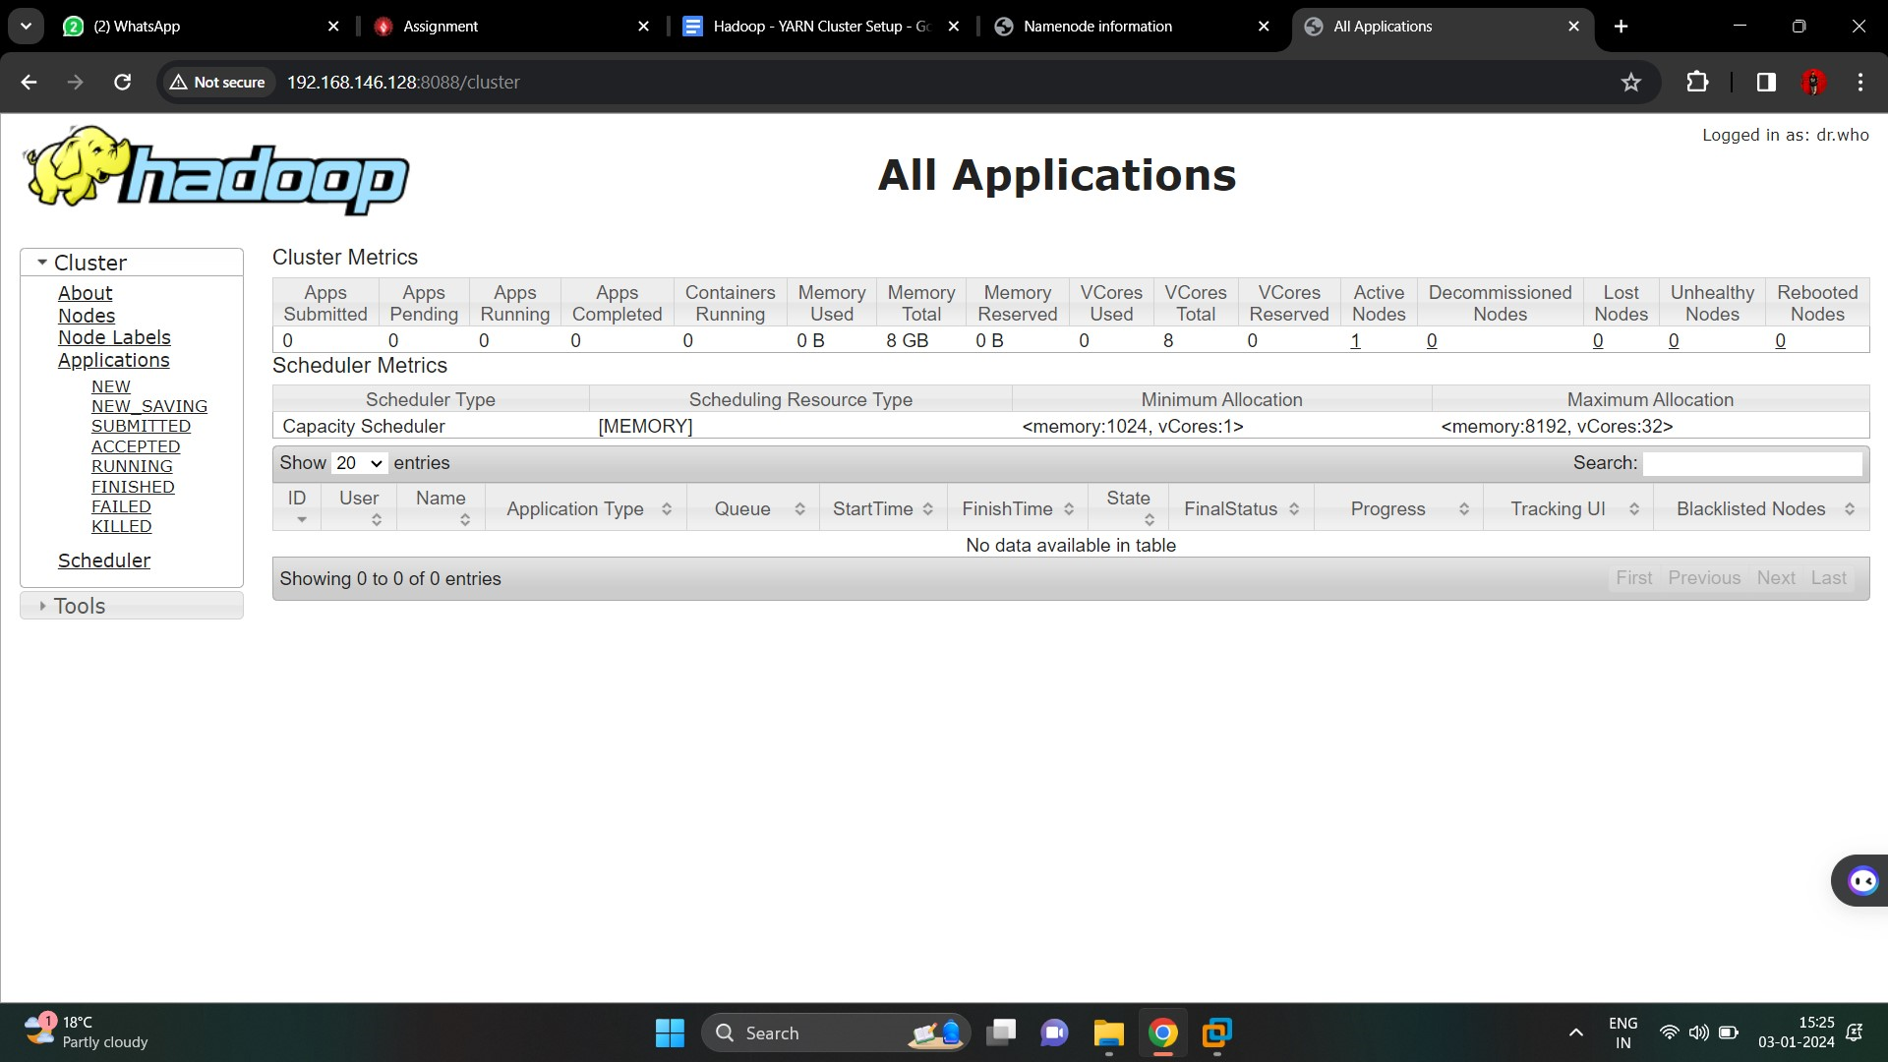

**Step 5:- Importing project file from windows to hdfs**

- create a folder in hdfs called project using (hdfs dfs -mkdir /project)

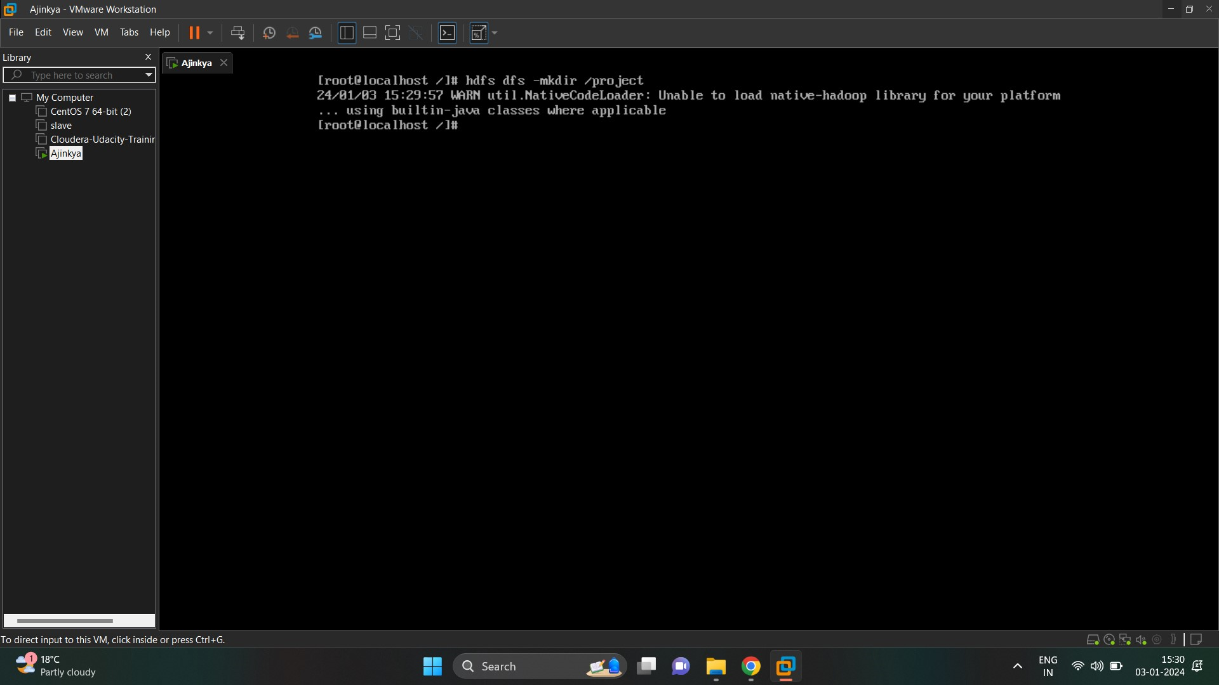

- move project file from windows to virtual machine’s root folder using FileZila tool

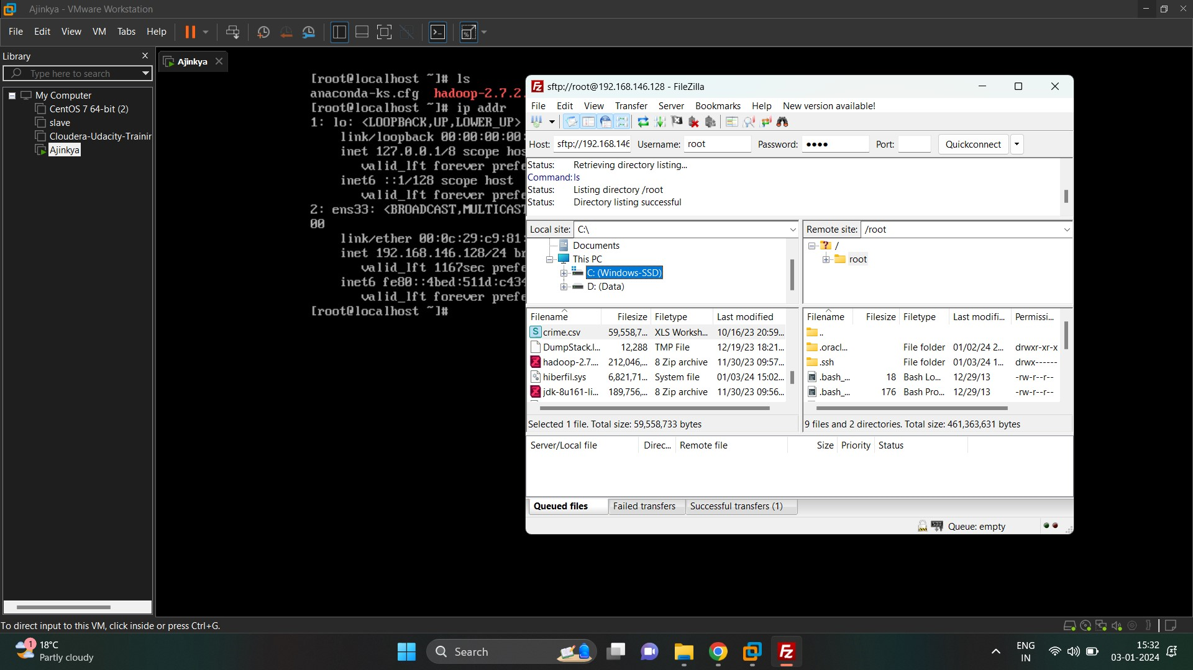

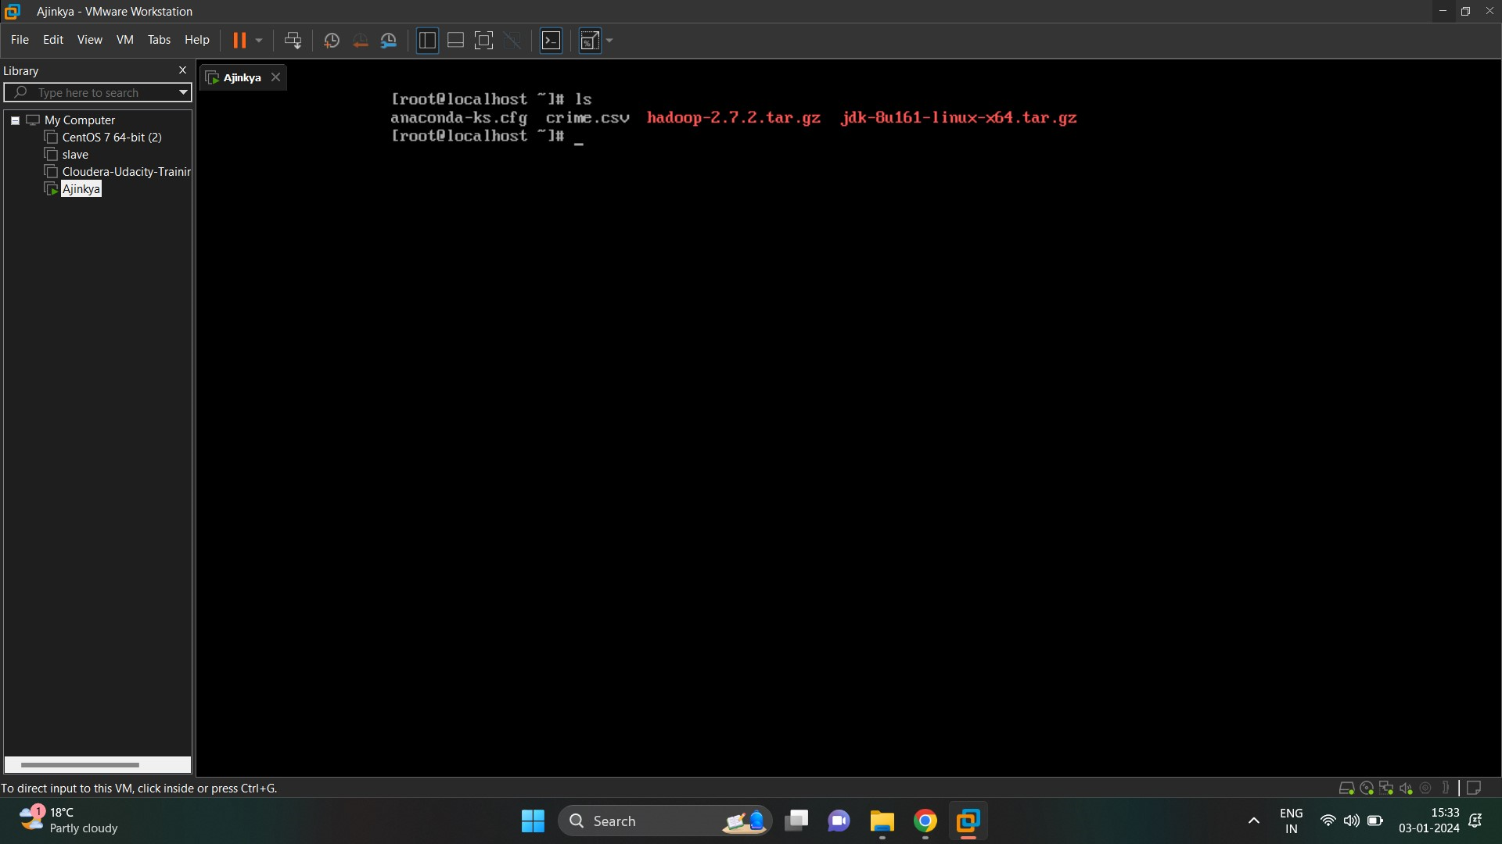

- move the file from local to hdfs using ( hdfs dfs -put crime.csv /project)

